Florida International University

Project #4
Functions, Loops
EML 4804 Introduction to Mechatronics

Submitted By:
Elyion Clyburn
PID 6410764
Date of submission:
10/06/2025

Fall, 2025
Introduction
The goal of this project is to learn how to conduct mathematical calculations, create functions, utilize loops, and timing functions while continuing our practice of implementing our code into a physical electronic component. By passing a range of values through a mathematical function and displaying the input and output values, I was able to practice writing code that communicates information to the user while gaining experience using functions and loops to ease the process of what would otherwise be tedious work. This project continued increasing my knowledge of embedded systems applications, where displaying information that gets passed through complex functions reliably is fundamental.

Materials used
- Breadboard
- Raspberry PICO board
- LCD screen
- Circuit wires

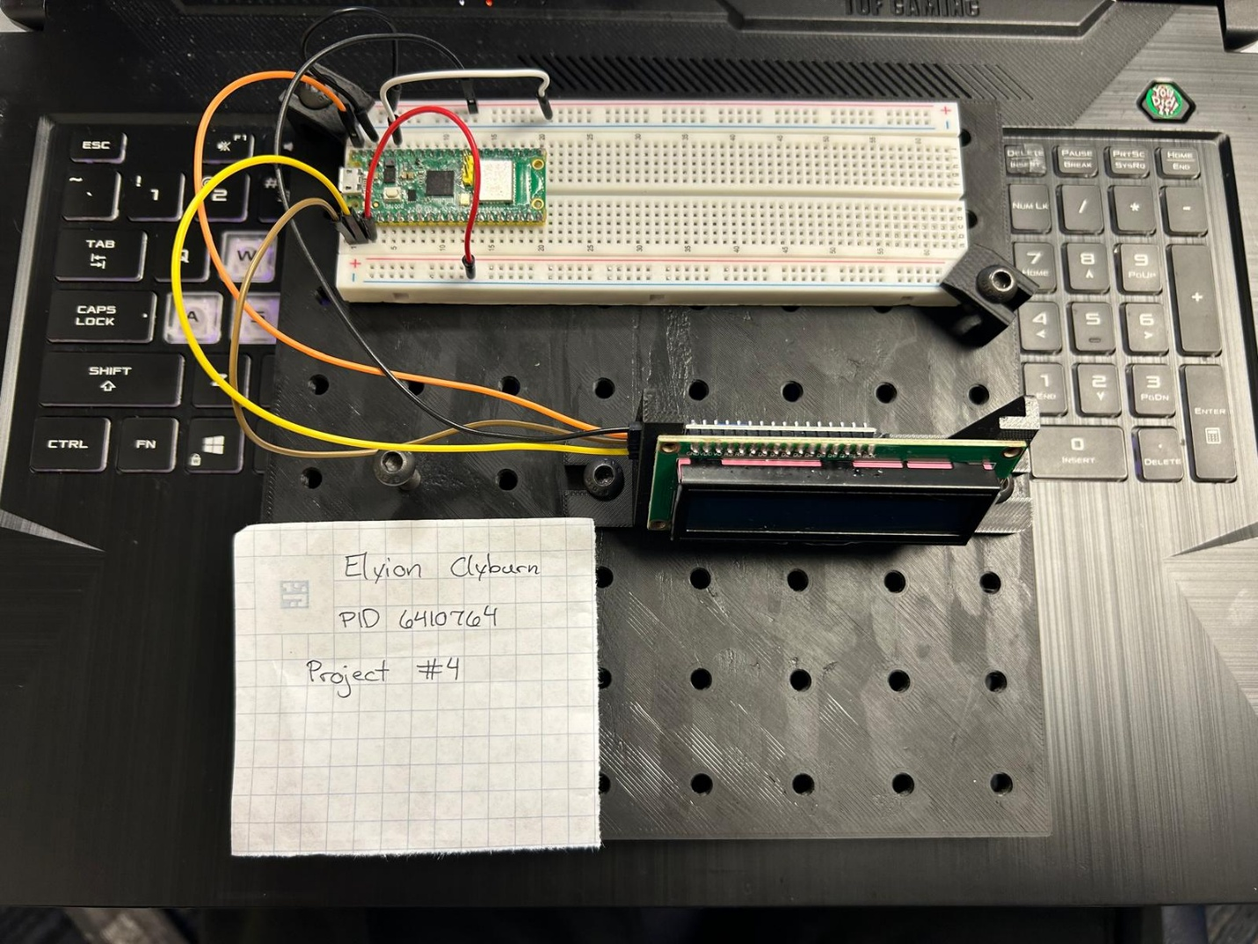
Picture
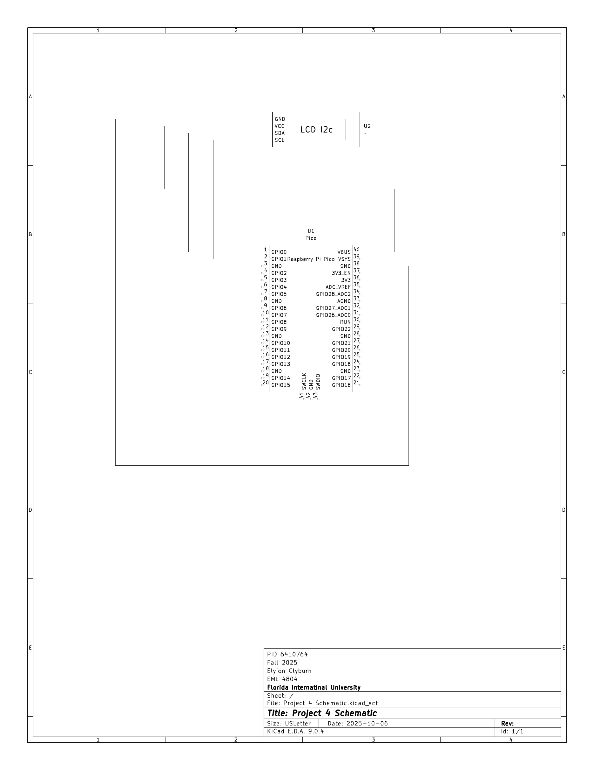
Code
#Importing the LCD library, math functions, and time
from lcd1602 import LCD
import utime, math

#Setting my start value
x = -4.5

#Displaying the expression and range
lcd = LCD()
string = f" Expression 4\n"
lcd.message(string)
utime.sleep(2)
lcd.clear()
string = f" y = (x^3)*\n ((sin(x/3))/8)"
lcd.message(string)
utime.sleep(2)
lcd.clear()
string = f" Minimum:-4.5\n Maximum: 0.5"
lcd.message(string)
utime.sleep(2)
lcd.clear()

#Solving for the y values and displaying the input and output
while x <= 0.5:
y = (x**3)*((math.sin(x/3))/8)
string = f" x:{x:.1f}\n"
lcd.message(string)
string = f" y:{y:.1f}"
lcd.message(string)
utime.sleep(2)
lcd.clear()
x += 0.1

Video Link
https://youtu.be/ufJPmJg6VqY

Conclusion
- What have you learned?
From this project I have learned how to pass information through a complex function and loop. I’ve also learned that I have the tendency to overcomplicate how I go about engineering problems, and that the solution is actually much easier (and shorter) than I may initially realize.
- How difficult was this assignment?
This assignment was difficult. I initially thought I would have to use 3 functions in order to complete it, but after talking with classmates, I realized that I was overcomplicating the assignment, especially since the code that I ended up using and loops made it a lot easier.
- How did you overcome challenges?
I had to do a lot of research in order to understand more about the operators and loops for this assignment. I even had to go as far as asking ChatGPT for help debugging my initial code before talking with peers made me realize I was doing too much. However, through my research and ChatGPT’s explanations, even though I didn’t end up doing my original code, I feel as though I understand more about programming.

References
Home Project #4 functions, loops Canvas Rubric
https://youtu.be/FhNWO68rsys
python - Limiting floats to two decimal points - Stack Overflow
Python math.sin() Method
https://chatgpt.com/share/68e436b8-fb38-8013-961f-81b55e107782

